**How Much Sugar Do You Drink?  
Student Worksheet S2/S3**

**ACTIVITY 1…**

On page 2 of this worksheet, draw lines to match up the teaspoons of added sugar to the corresponding drinks.

**ACTIVITY 2…**

Materials needed:

* Package of sugar
* Plastic resealable bags
* Teaspoons
* Poster – How Much Sugar Do You Drink?

Place the correct teaspoons of sugar into the plastic bags to match the drinks on the poster. Attach the plastic bags of sugar to the poster to show how much sugar is in each drink.

**ACTIVITY 3…**

Why is it unhealthy to eat or drink too much sugar? ___________________________

____________________________________________________________________

How often should you have drinks with added sugar? _________________________

Is water an ‘everyday’ drink or a ‘sometimes’ drink? __________________________

How many cups of water do YOU drink each day? ____________________________

How many cups of water does your body need every day? ____________________

Water is important to your body because __________________________________

___________________________________________________________________

List some ideas to help you drink more water: _______________________________

____________________________________________________________________________



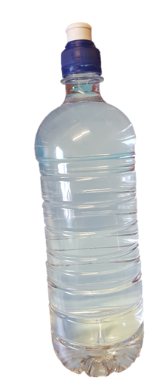

**6**

**teaspoons**

**Drink**

**Draw Matching Line**

**Teaspoons of ADDED Sugar**

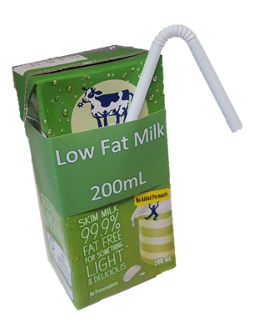

**2**

**teaspoons**

**13   
teaspoons**

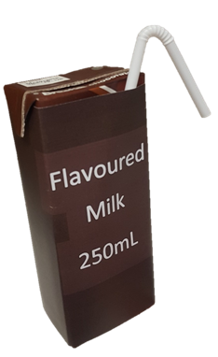

**7   
teaspoons**

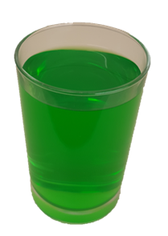

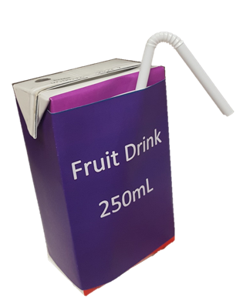

**3   
teaspoons**

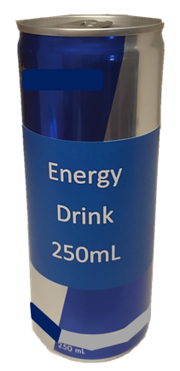

**No   
Added   
Sugar**

**6**

**teaspoons**

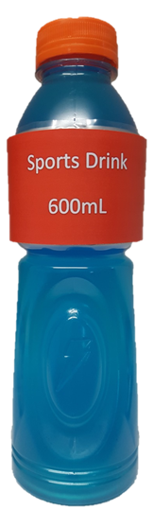

**8   
teaspoons**

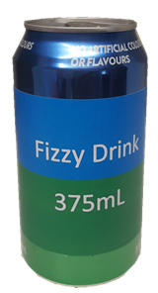

**No   
Added   
Sugar**

